Surf Life Saving   
**xxx Program 2024**

**LOCATION**

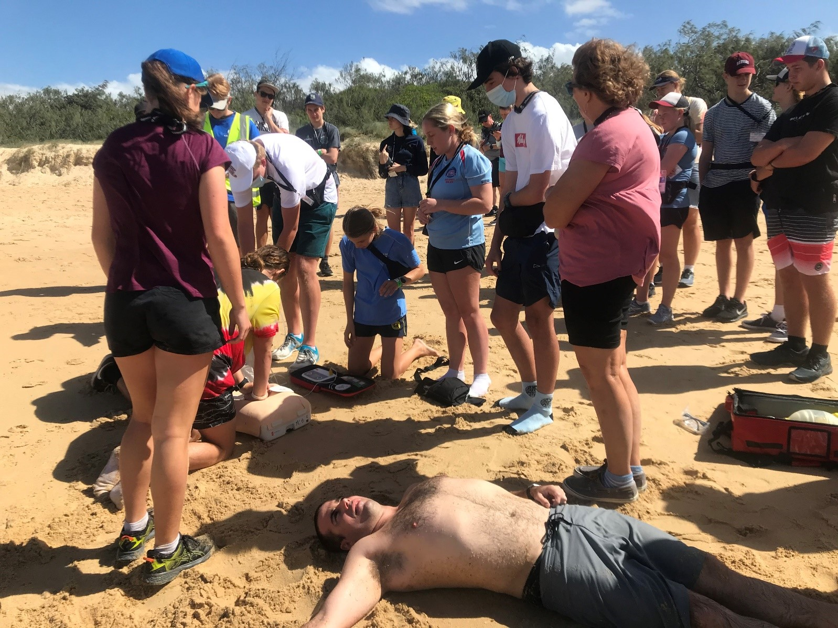  
WELCOME PACK

Contents

What is the Lifesaving Development Program? 3

Program Details 4

Coordination Team 4

Leaders 4

Presentations 4

What to bring 5

Transport 5

Training Information 6

Scenario-Based Training 6

Prerequisites 6

Awards 6

Personal Information 6

Medical & Dietary Requirements 6

Online Enrolment 6

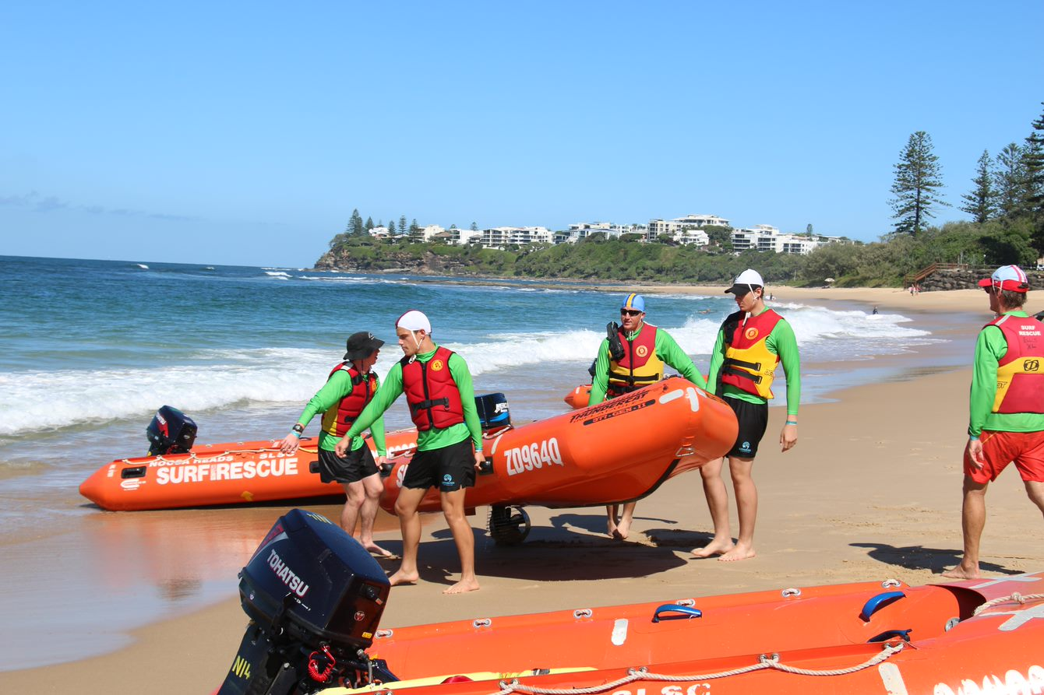

**xxx Program**

***Congratulations*** and welcome to the Surf Life Saving xxx Program! As part of your selection into this year’s program, you have been identified by your Surf Club as being a future leader and role model within Surf Life Saving (SLS). With this selection in mind, it is important that you are aware of the responsibility you carry and that the behaviour and attitude you bring to the program reflects on you and your Surf Club. Please note, this Welcome Pack is full of important information that you will need to know. **So, keep reading!**

The program is filled with tons of fun and exciting learning activities that will challenge you both on a mental and physical level. It will also push you out of your comfort zone to achieve things you never thought possible. With inspiring leaders and guest speakers from all different areas of Surf Life Saving, you will have the opportunity to learn more about what this great organisation has to offer whilst learning and developing new skills along the way.

The program will see xx participants representing clubs from across BRANCH come together with a leadership and management team of more than xx people. Your attitude, enthusiasm and commitment to your team and your leaders will play a huge role for your groups’ success in the activities we have planned. We hope you are as excited as we are!

# What is the xx Program?

PROVIDE DETAILS AND OVERVIEW OF THE PROGRAM AND ITS OBJECTIVES

# Program Details

Arrival: DATE & TIME

Leave: DATE & TIME

Location: SITE NAME & PHYSICAL ADDRESS

## Coordination Team

## SLSQ Staff

## Leaders

# Transport

INCLUDE INFORMAITON FOR:

* BUS PICK UP/DROP OFF
* PARENT PICK UP/DROP OFF
* FLIGHTS
* INFORMATION RELEVANT TO IF PARTICIPANTS ARE ABLE TO DRIVE THEMSELVES.

INCLUDE MAPS FOR BOTH BUS AND PARENT

# What to bring

You will need to bring the following to the program:

* Casual clothes sufficient for each of the 7 days (*all weather conditions*)
* Warm clothing (*Autumn is here; temp. range 18-26o*)
* Pyjamas
* Thongs (*for showering*)
* Runners / enclosed shoes (*2 pairs in case one gets wet*)
* Backpack / day pack (*for travel to the beach*)
* Sun protection – hat, sunglasses, sunscreen & zinc
* Waterproof jacket
* Swimmers (preferably club swimmers, *not bikinis*)
* Plastic bag for wet clothes / towels
* High vis rashie
* Wetsuit (*optional for IRB and if available to you*)
* Beach / bath towels x 2
* Pillow
* Torch
* Insect repellent
* Sleeping bag / sheets and blanket (king single)
* Toiletries
* Water Bottle
* Pens, pencils, highlighters etc
* Club noddy cap
* Old clothing that can be destroyed
* Electronic device (refer to Here).
* A positive and enthusiastic attitude

# Personal Information

## Medical & Dietary Requirements

If you have any medical or dietary requirements that you did not list in your application or that you believe require further discussion, please contact XXX.

Please ensure if you have a history of asthma or anaphylaxis that you have informed the Camp Coordination team prior to the camp commencing.  Any candidates with anaphylaxis must supply an Epi Pen for the duration of the program.

If any candidate has a Medical Management Plan for any condition, please provide a copy to XXX prior to the Program.

**Your Contacts**

If you have any concerns or questions in the lead up to the program, please do not hesitate to reach out to one of the below. The below can also be used for any urgent issues or questions throughout the duration of the program itself.

|  |  |
| --- | --- |
| **NAME** | **NAME** |
| SLSQ Staff | Program Coordinator |
| M: | M: |
| E: | E: |