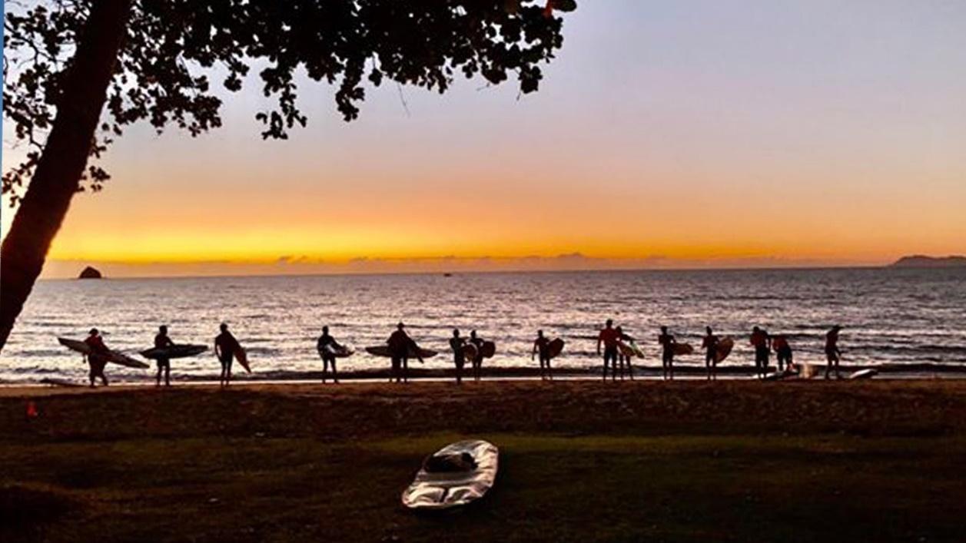D

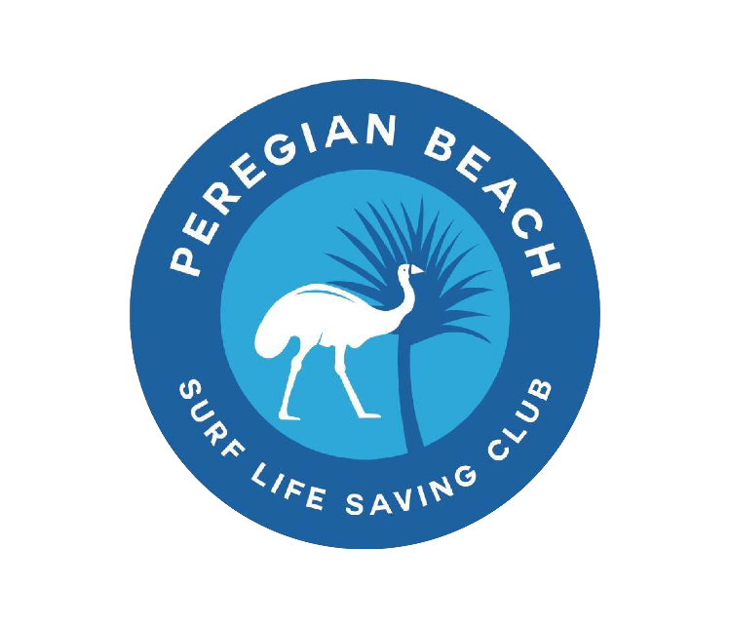

**Contents**

SLSQ Code of Conduct 3

Welcome to Club 4

Child Safety 5

Age Competencies 6

Parent Involvement 7

Sign-On and Sign-Off Proposal 8

SLSQ Code of Conduct

Lorem ipsum

Welcome to Club

Lorem ipsum

Child Safety

Lorem ipsum

Age Competencies

Lorem ipsum

Parent Involvement

Lorem ipsum

Sign-On and Sign-Off Proposal

Lorem ipsum

For more information about SLSQ Junior Activities, including child safety initiatives, neurodiversity support, and helpful resources for age managers, parents and clubs, visit our website.

SLSQ Contact

**Address:** 18 Manning St, South Brisbane QLD 4101

**Phone:** (07) 3846 8000

**Email:**[slsq@lifesaving.com.au](mailto:slsq@lifesaving.com.au)

Club Contact

**Address:**

**Phone:**

**Email**